The following are rough screens. Please bear with this as I am using my notebook to create this scrap doc using mouse pad.

No Matter which user logs in [Company Admin, Franchise Admin or a regular User]. They will see similar UI.

Only difference would be one or the other will have more or less Modules in the Command Center.

And the company Logo and name will be different under each franchise.

Agree till this point

Company Admin will have the following modules
- Login Module [Change Password]. - OK
- Manage Sub domains. [Add/Delete sub domain, Add/Delete Module] - OK
- Manage Company Name/Logo. Main controller site should have three boxes horizontally aligned to see advertisements. Super Admin / Company Admin will have small CMS to manage these advertisements and can update / add / delete advertisements for main controller site. In general light CMS is needed.
- Manage Documents [Add/Delete Documents]. – Need to check if this is needed for super admin as most of the documents are related to franchise and each franchise should manage his own documents for his franchise
- Manage Notifications [Email etc]. – This is needed to centrally know which Franchise is working smooth, no dues from Franchises etc.
- Manage Calendar [Send/receive/reject meeting request]. – This is needed
- Manage Finance. – Not needed at controller site. Each Franchise should have Finance / Accounting module. This module is not for Controller or Company admin. Lets discuss on this more.

Franchise Admin:
- Login Module [Change Password]. - OK
- Manage Users, Add Delete Module to User. - OK
- Manage Company Name/Logo. - OK
- Manage Documents [Add/Delete Documents]. - OK
- Manage Notifications [Email etc]. - OK
- Manage Calendar [Send/receive/reject meeting request]. - OK
- Manage Finance – OK
- Manage Vendors and Contracts
- Manage bills, receipts for members and complete accounts
- Manage Secretary (shadow Franchise manager)
- If bills are not paid on time and contracts expire then generate reminders
- Upload minutes of meetings document and display it on webpage
- Upload Circulars and then send all those circulars automatically through email to all users
- Format Module – All the forms required by Franchise should be available to all users dully filled their respective names and user number (employee number)
- Search Feature
- Backup and Recovery module

User:
- Login Module [Change Password].
- Manage self profile, picture.
- Manage Documents [Add/Delete Documents].
- Manage Notifications [Email etc].
- Manage Calendar [Send/receive/reject meeting request].
- Manage Finance.

We can add as many modules as we want. Do you see my point here? Yes. Understood.

This is our Main Company Login
The Company Admin Logs in here to the main web site.

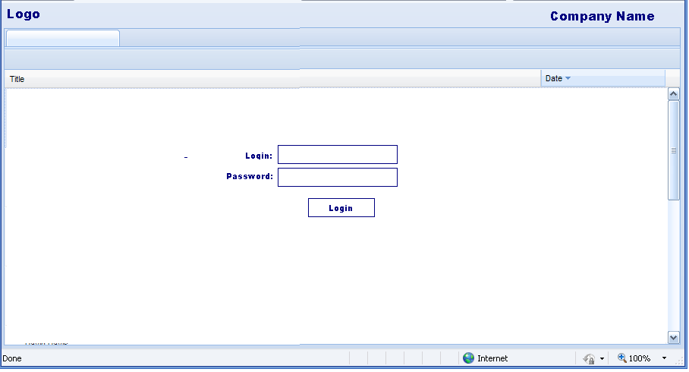

Here the Company Admin will be able to create Sub Domains and add/remove modules for franchise.
If we develop new modules and upload to the server it will automatically appear in Company Admin’s Command Center. Agree and understood
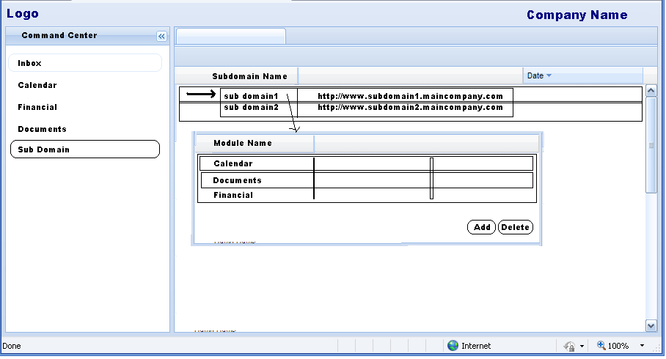

After the Company Admin has created the sub domain. The Franchise Manager can use his login and pwd to login to his subdomain
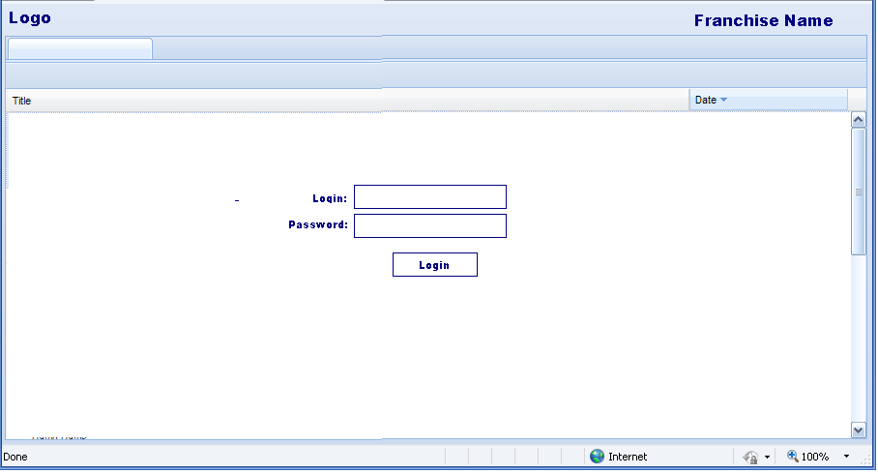

In the following screen franchise manager can add/update delete user account. Agree
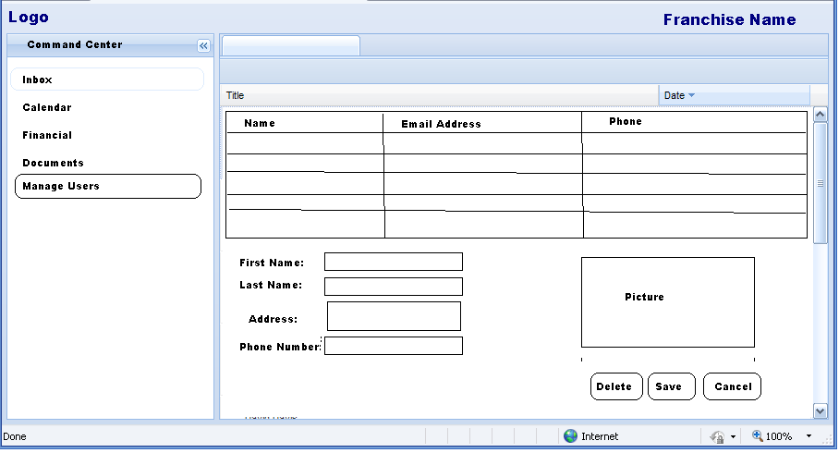

This is the calendar module..
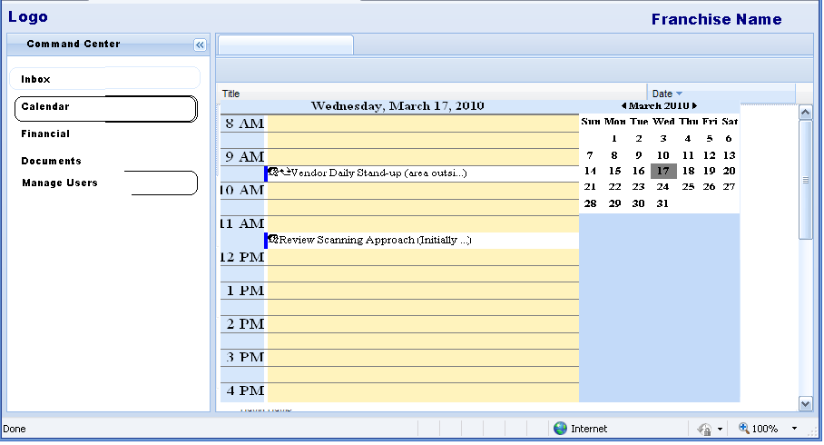

I will be creating only one Web Service, this is the Main Service.
Initially the app will do an Authenticate call which will return an encrypted string if success.
All subsequent call to the Main Service will attach the encrypted string to the service.

Pseudocode:

Login()
{
ResponseObject obj = ServiceUtility.ExecuteService(“Authenticate”, xmlLoginInfo);
If( obj.ReturnCode == 0 )
{
String encryptedString = XmlUtility.Deserialize(obj.body);
Session[“EncString”] = encryptedString;
}
}

The above encrypted string is stored in session variable on server. So that the user can navigate from page to page.

Without the encrypted string in session no service method may be called.

Agree and understood

Eg:- ChangePassword

ResponseObject obj = ServiceUtility.ExecuteService(“SecurityServices.ChangePwd”, xmlChangePwdInfo);

If( obj.ReturnCode == 0 )
{
Success!!!;
}

As you see here to call a service you will only use the ServiceUtility.ExecuteService method. This is the only Web Service exposed. Agree

Internally there will be a Mapping for the Message to appropriate Service Module and class and method. Using reflection I will be instantiating the class and service.

This way when deploying new Module all you will have to do is deploy the ModuleService dll and its UI page [Not sure if independent UI deployment is feasible]
Nevertheless we can always recompile the UI and deploy to main site during outage.
(hmmmm this needs to be discussed.)
The ease is that in future one need not worry of WebService as he/she will only need to create Service and create a Message mapping.

